**Project Report On Fees Management**

**Submitted To:**  Mrs. Vandana Gautam

**Submitted By**: Prachi Anand

**Roll No**: 17604138

**Session**: 2021-2022

**Index**

* Certificate
* Acknowledgement
* Introduction
* Technologies Used
* Analytics
* Source code
* Output
* Bibliography

**Certificate**

I hereby declare that the work which is being presented in this project entitled **“Fees Management”,** submitted at **Cecil Convent School, Ambala Cantt**is an authentic work done during the period **2021-22** under the guidance of **Mrs. Vandana Gautam*.*** The work presented in this project report has not been submitted by me in other school.

SIGNATURE OF THE STUDENT

This is to certify that the above statement made by the candidate is correct to best of my knowledge and belief.

SIGNATURE OF THE SUPERVISOR

**Acknowledgement**

The satisfaction which comes on completion of any task would be great but it is meaningful without thanking those people who gave me constant guidance, knowledge and technical inform about my project.

So, this is to thank those people who helped me at every stage and every difficulty which I faced in completion of my project. So, my first thanks goes to my subject teacher **Mrs. Vandana Gautam** for her guidance and personal supervision throughout this project. I would also like to thank my **parents** as they encouraged me to put forward my project.

**Introduction**

This project “Fee Management System” is a desktop system enables efficient storage of student records to properly manage the fee records of the students. And it also generate messages for due balances it students fee. The system is designed for fee management of a college administration department. It makes searching records easier and faster.

**Technologies Used**

**SOFTWARE SPECIFICATION:**

Operating System: WINDOWS 10

Platform: Python IDLE 3.9

Database: MYSQL

Languages: Python

**HARDWARE SPECIFICATIONS:**

* DESKTOP-DQKDPI1

Processor: Intel® Core ™ i3-2370M CPU @ 2.40GHz

Hard Disk: 95.3GB

RAM: 2GB

* Printer
* USB Storage Device

**Analytics**

The data set collected here is related to school student being analyzed for future use.

**Time Period:** 6 Months

**Use:** To enter students record and to check their fees status.

**Source Code**

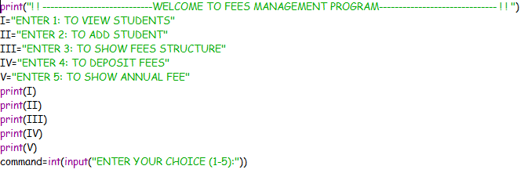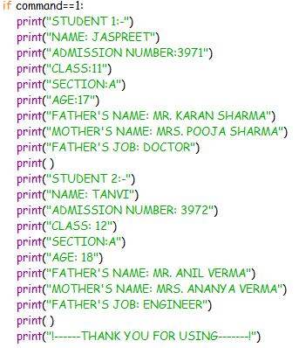

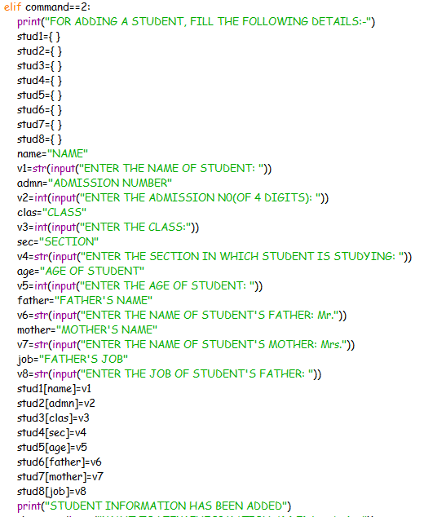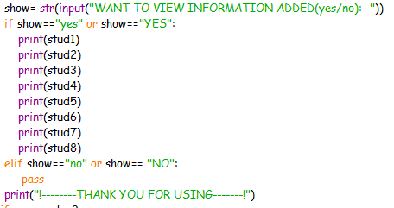

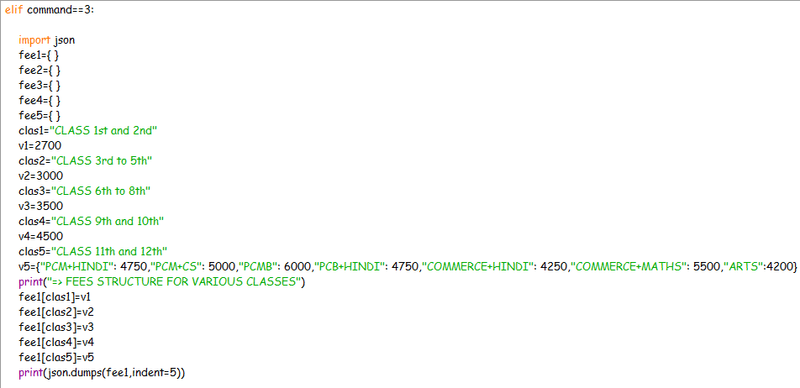

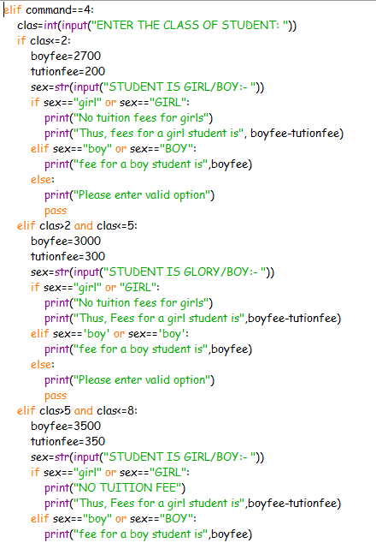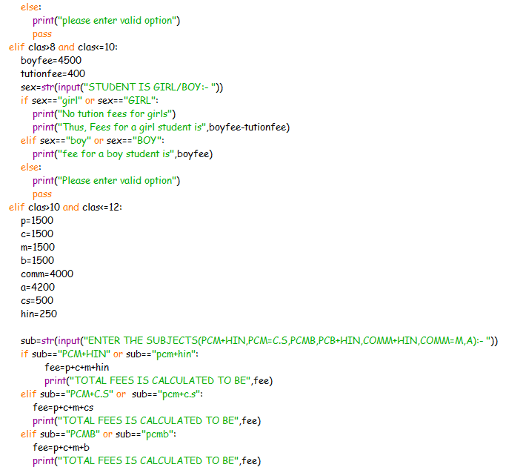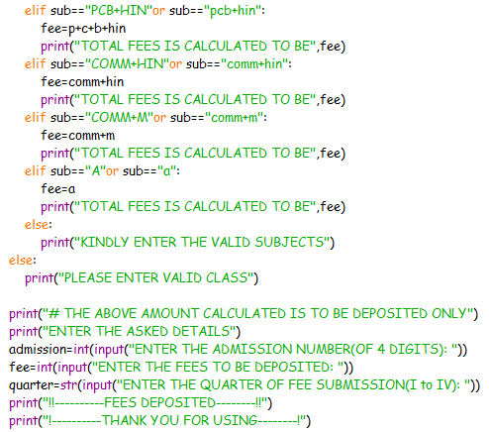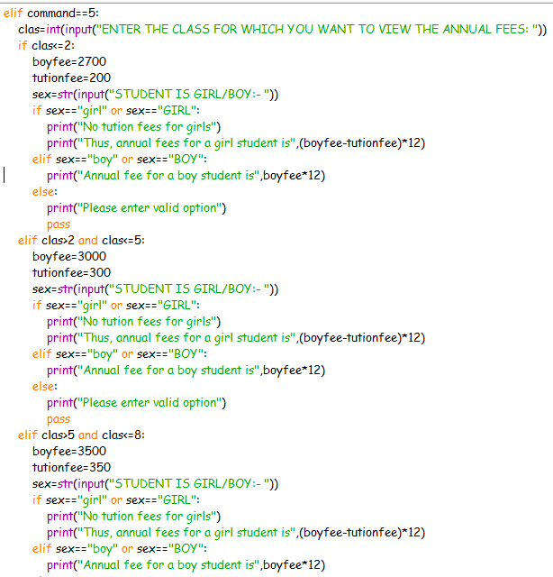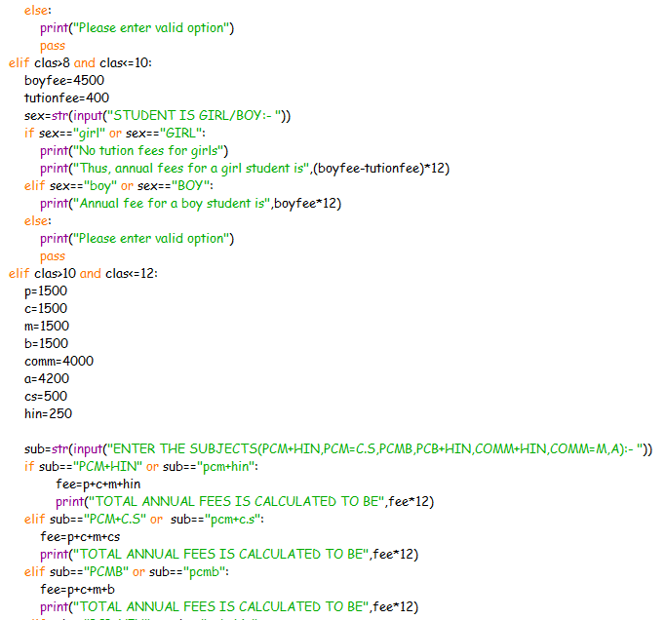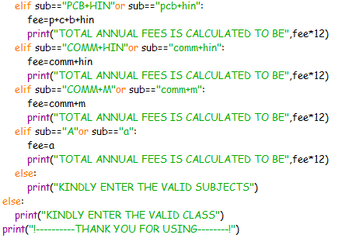

**Output**

**TO VIEW STUDENTS:**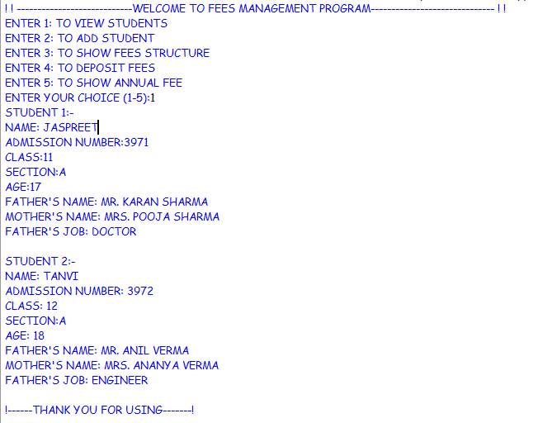

**TO ADD STUDENT:**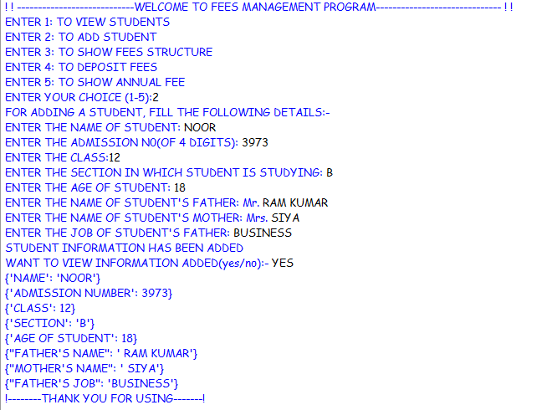

**TO SHOW FEES STRUCTURE:**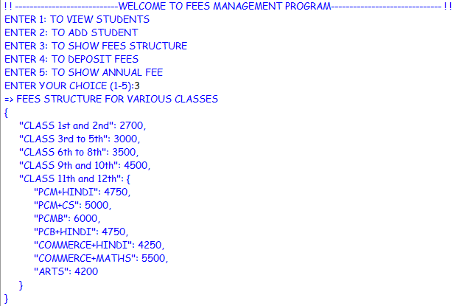

**TO DEPOSIT FEES:**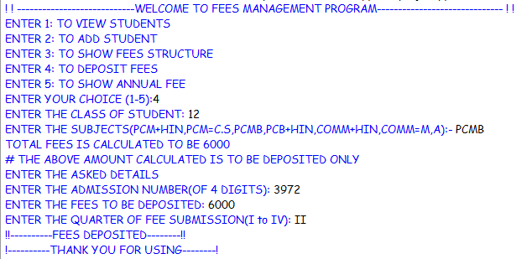

**TO SHOW ANNUAL FEE:**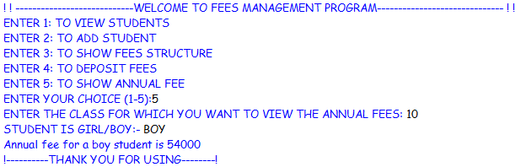

**Bibliography**

* Head first python by Paul Barry
* Fluent python by Luciano Ramalho
* [www.youtube.com/watch](http://www.youtube.com/watch)
* www.google.com